

Atlanta Koi & Goldfish Show - 2014
September 12-14, 2014

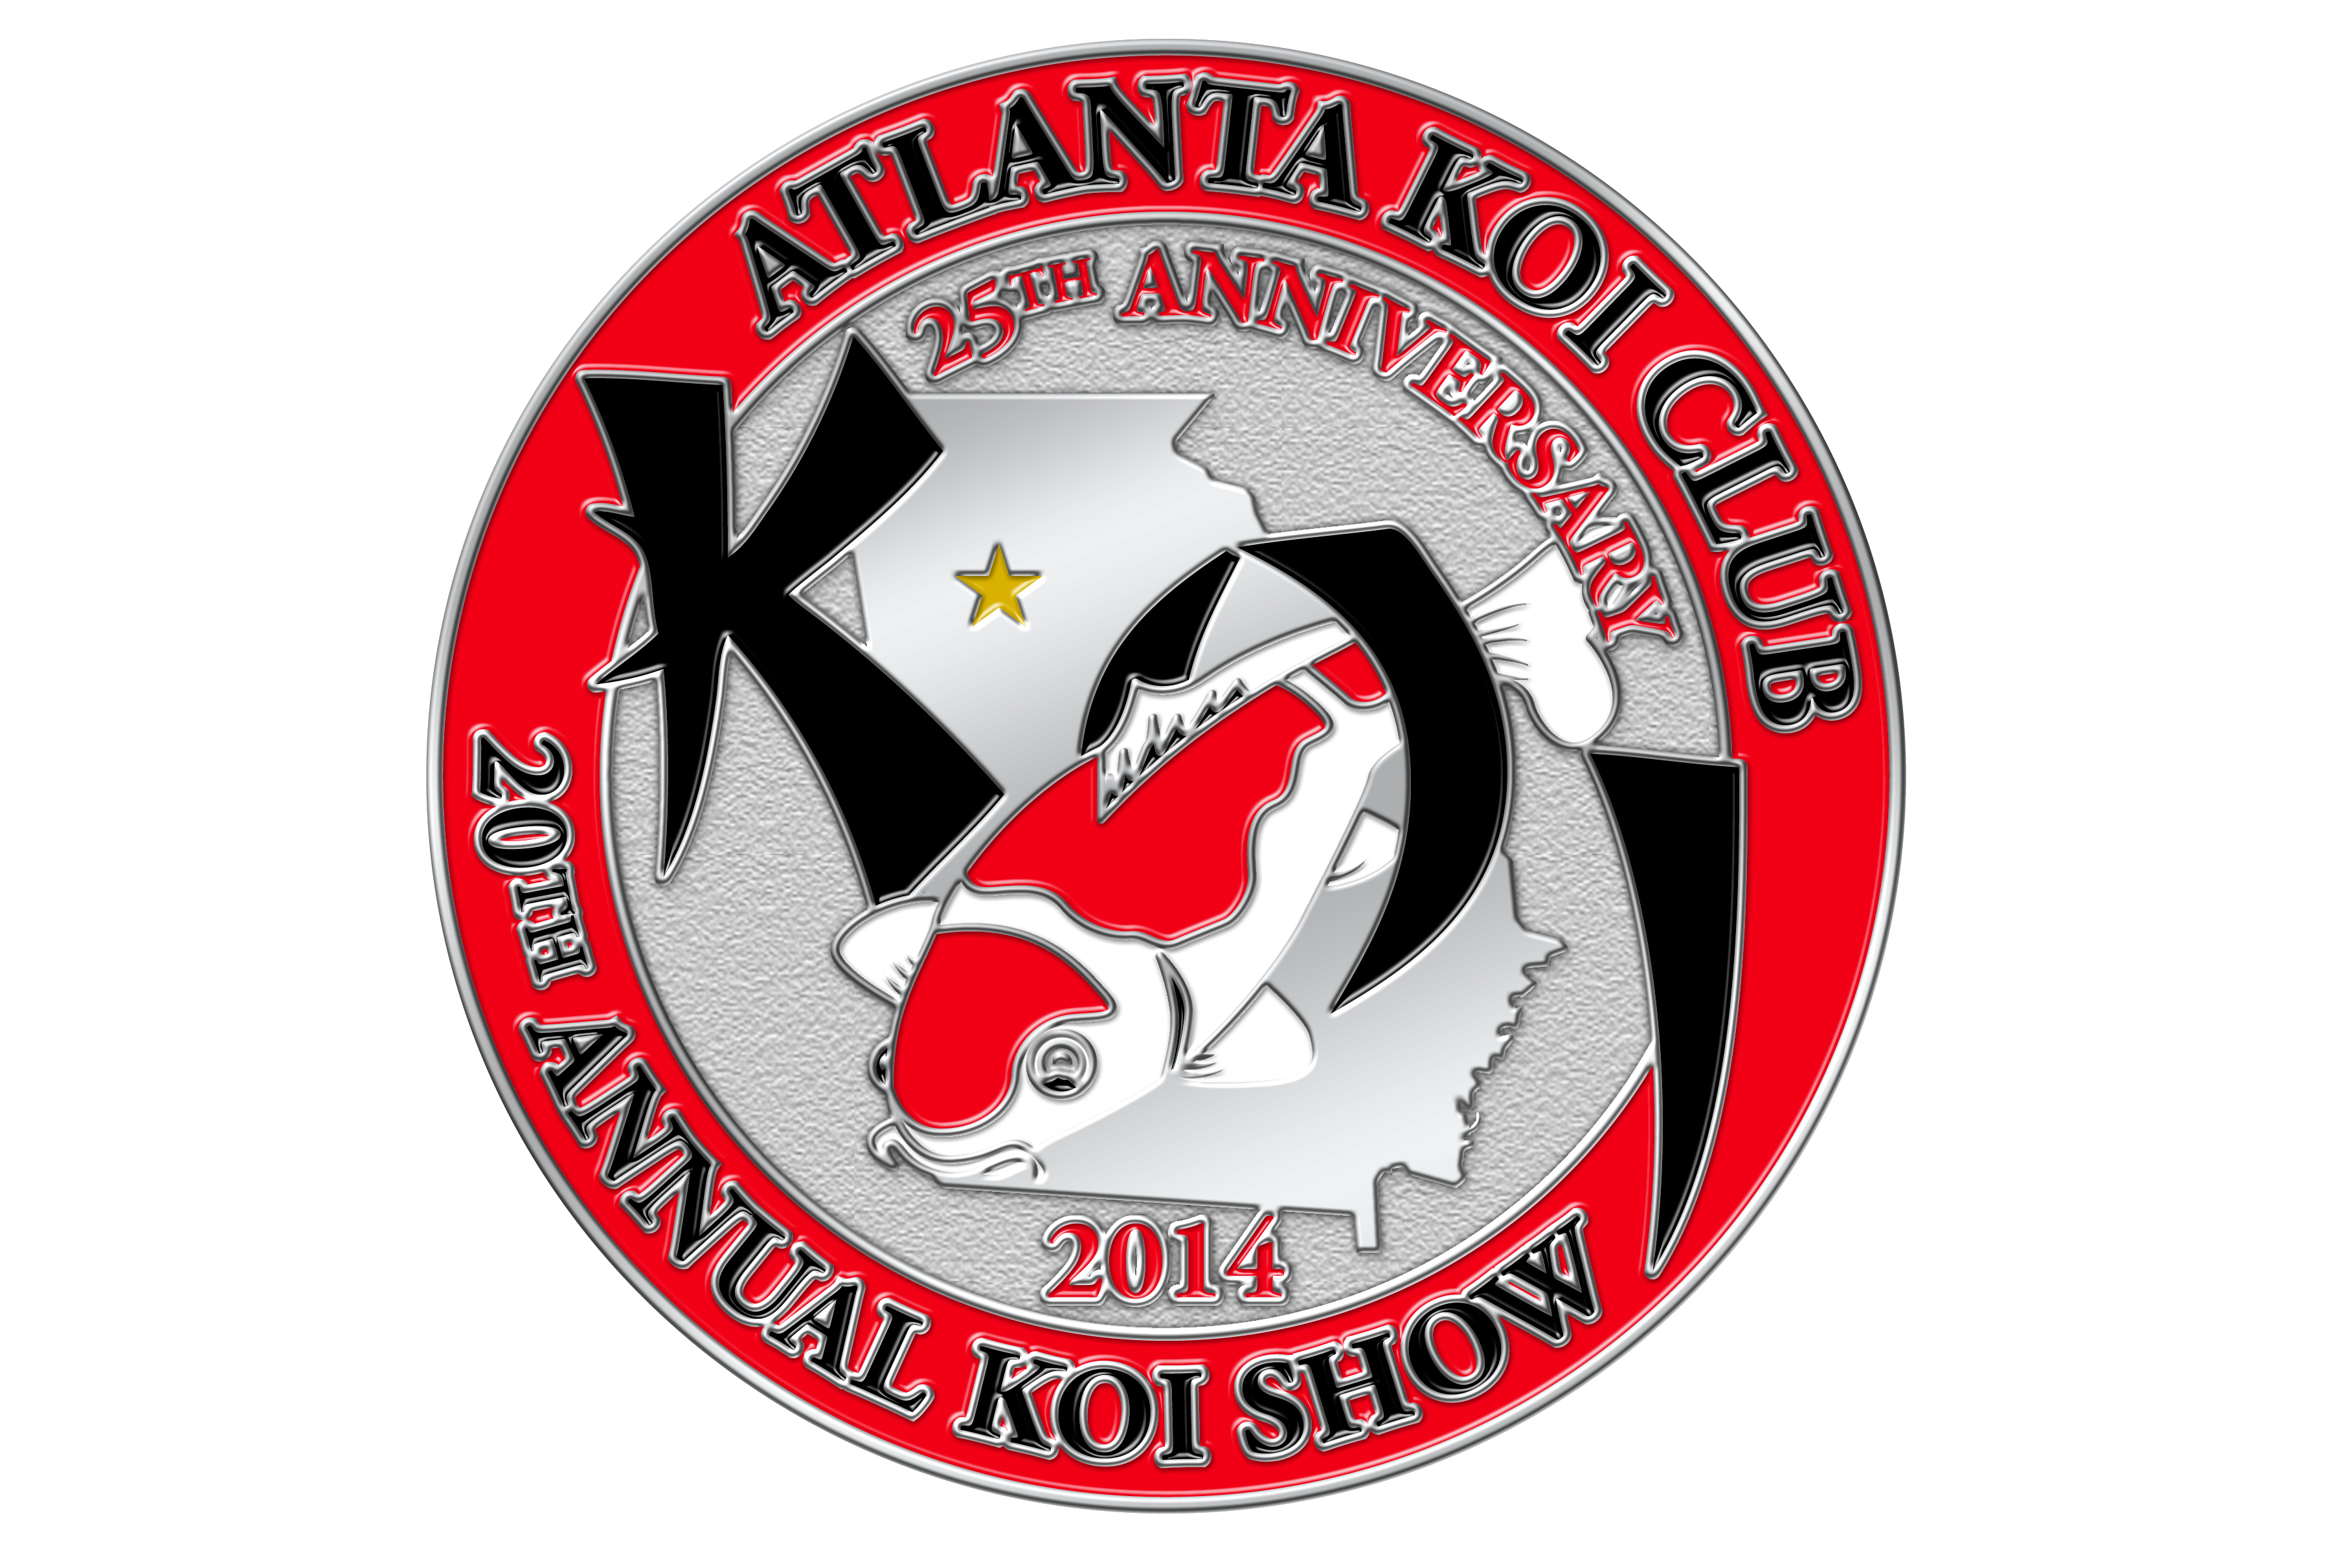

Coastal Pond Supply
2110 Tucker Industrial Road
Tucker, GA 30084
(800) 782-6179 (770) 496-5740

Vendor Information

History – This year the Atlanta Koi Club (AKC) celebrates its 25th anniversary as a club and its 20th annual show. Several years ago the club introduced the exhibition of goldfish to the show and has been rewarded with great enthusiasm from goldfish and koi fanciers alike. We hope that the Atlanta Koi & Goldfish Show - 2014 will be our biggest and best show yet! As in the past we will host separate nishikigoi, longfins, and goldfish competitions.

During the past 19 years, we have relied on your support to make this a great weekend full of all things pertaining to koi and goldfish. We’re making every reasonable effort to have all people that have contributed to this success return to help us celebrate these wonderful 20 years. Your presence, support, and continued contribution have been the #1 reason for our success.

We will keep you informed via our website, www.atlantakoiclub.org, as the show date of September approaches on our schedule of events. We are pleased to announce that the following individuals have accepted our invitations to judge this year:

Koi/Long fins
- Dale Gingerich – Head Judge
- Richard Porter - Judge

Goldfish
- LuAnn Porter

The vendor show is held indoors at Coastal Pond Supply so weather is not a major concern. In addition to the koi and goldfish show, we have numerous fish vendors, dry good vendors and artisans. Coastal Pond Supply is a non-smoking facility, but we will have areas outside set aside for the smokers among you.

Hopefully, this information packet answers all of your questions, but if you need more information contact Gary Elmore at koishow@atlantakoiclub.org

Show Schedule

Setup
9/11/2014 | Thursday | 8;00 AM – 6:00 PM
9/12/2014 | Friday | 8:00 AM – 6:00 PM
Benching
9/12/2014 | Friday | 11:00 AM - 6:00 PM
9/13/2014 | Saturday | 8:00 AM - 9:00 AM (Overflow Only)
Show Hours
9/13/2014 | Saturday | 9:00 AM - 5:00 PM
9/14/2014 | Sunday | 9:00 AM - 2:00 PM
Judges’ Critique
9/14/2014 | Sunday | 10:00 AM - Noon
Vendor Appreciation
9/12/2014 | Friday | 7:00 PM – 10:00 PM
Awards Banquet
9/13/2014 | Saturday | 6:00 PM – 7:00 PM (Cash Bar)
9/13/2014 | Saturday | 7:00 PM – 10:30 PM (Dinner/Awards)
Tear Down
9/14/2014 | Sunday | 2:00 PM - Finished

Booth Information
- All vendor spaces include: Dry vendors, $150 first booth, $250 for two booths.
  - 10 ft. x 10 ft. Booth Space as indicated in detail
  - Electrical drop
  - 6 foot Table – 1
  - Chairs – 2
  - Food – Friday night reception, Saturday & Sunday lunch
- Wet vendor spaces include: $250 first booth, $350 for two booths, additional tanks, $50
  - 7’ – 500 gallon tank for each booth
  - Water for tank

Vendors are responsible for supplying any other materials they will need to make their participation successful.

Competition Tank for Your Client’s Fish - The Atlanta Koi Club provides show tanks for dealers who sell fish to be entered into the show. Entrants not showing other fish in the show must register their own fish. There is a $5 charge per individual which is waived for Atlanta Koi Club Members. Fish must be in the community tanks by 8:30 am Saturday. No fish are to be placed in a tank until registration is completed. This includes the digital photo. The actual owner of the fish must be present at the time of benching.

Since this is a hobbyist-only show, all fish entered must be owned by and accompanied by the registered entrant. Koi or Goldfish dealers or their employees, even part time or informal fish dealers are not allowed to show fish.

Hospitality - AKC will showcase its famous southern hospitality with a Vendor Appreciation Night on Friday night from 7 PM to 10 PM. The event will feature excellent food, hosted beer and wine bar, and assorted non-alcoholic beverages. This is a great opportunity to meet the judges, mingle with other Koi hobbyists, vendors, club members and exhibitors.

We encourage the vendors to be open for business to give attendees an early chance to shop.

Awards Banquet - The banquet is scheduled for 7:00 PM on Saturday night. A cash bar beginning at 6:00 PM will precede the banquet. Tickets are $35 per person, 2 tickets for $60. Advance reservations are highly encouraged. Prior to the show, banquet reservations are available through koishow@atlantakoiclub.org, with your advance vendor registration, or through eligible trophy sponsorship. If reservations remain available at the show they can be purchased at the AKC Store.

Raffle Donations – Donations of raffle items are welcomed. Raffles are held throughout the weekend with the proceeds benefitting the Atlanta Koi Club to assist in deferring the cost of the show. If you prefer, your donation may be designated to be auctioned during the Awards Banquet on Saturday night.

Vendor donations are greatly appreciated for either purpose. If you wish to donate discount certificates for use at your booth the AKC will have these available at the show. These certificates provide you with a great exposure at a minimum cost. The Atlanta Koi Club is a non-profit organization so donations may be tax deductible.

Cancellation Policy- No refunds of reservation fees will be made unless the booth can be rented prior to the show, then a full refund of advance fees will be made after the show.

Hotel Reservations – A block of rooms has been reserved at the Comfort Suites Northlake, 2060 Crescent Centre Blvd, Tucker, GA – the rates are $75.99 for a King or Double (2 Queen Beds) (no pets allowed, unless they are assistance dogs).
Full breakfast available for hotel guests.
Complimentary wireless high-speed internet access is included with your reservation.
Any reservations after August 27th will be booked at their regular room rates.
For a reservation, call the number listed below and ask for the preferred rates for Atlanta Koi Club or Atlanta Koi Show. You can make reservations directly using this link,

Comfort Suites Northlake

The Saturday evening Awards Banquet is just 5 -10 minutes from the hotel.
Directions to Show from Host Hotel
Comfort Suites Northlake
2060 Crescent Centre Blvd
Tucker, GA 300
770-496-1070

Directions FROM hotel TO Atlanta Koi and Goldfish Show (3.6 miles)

- Turn Right onto Northlake Pkwy. Proceed .6 mile.
- Turn Left onto Lawrenceville Hwy. Continue for 2.4 miles.
- Turn Right onto Tucker Industrial Rd. Continue for .3 miles.
- Atlanta Koi Show (Coastal Pond Supply) will be in warehouse on right side.

Directions FROM Atlanta Koi and Goldfish Show TO hotel (3.6 miles)

- Turn Left (heading West) out of Coastal Pond Supply Parking onto Tucker Industrial Rd. Proceed for .2 miles.
- Turn Left onto Hugh Howell Rd / GA-236. Continue for 2.4 miles.
- Turn Right onto Northlake Blvd. Continue for .6 miles.
- Turn Left on Crescent Center Blvd., hotel will be on your right.

Directions to Show Site
From Atlanta’s Hartsfield-Jackson Airport- Exit the airport on to I-85 South. Follow signs toward Macon and I-285 East. Go eastbound on I-285 East (forget about Macon) about 20 miles to exit #39, Highway 78, exit East towards Stone Mountain. Take HWY 78 (Stone-Mountain Expressway) to the second exit, Mountain Industrial Blvd. Turn left. Go North over HWY 78 and turn left in 2–3 blocks just after Sam’s Club on your left. Go one short block, and turn right. We are ½ block up Tucker Industrial Road on your left.

From Atlanta/I-285-Take Route 78 (Stone-Mountain Expressway) East from I-285 to the second exit, Mountain Industrial Blvd. Turn left. Go North over 78 and turn left in 2 – 3 blocks just after Sam’s Club on your left. Go one short block, turn right; we are ½ block up Tucker Industrial Road on your left.

Honoring Koi Bucks - The Koi Bucks program is a way to encourage members to generate additional sales with the show vendors. The Atlanta Koi Club has issued Koi Buck certificates to many club members as rewards during the year. Each new certificate is in a $10 denomination, there may be some older $20 and $30 Koi Bucks’. We ask each vendor to honor the Koi Buck certificates for their face value. A club member may have more than one Koi Buck. Please bring the Koi Bucks to the club booth were we will exchange them for cash. We will make the cash exchange only for registered vendors.

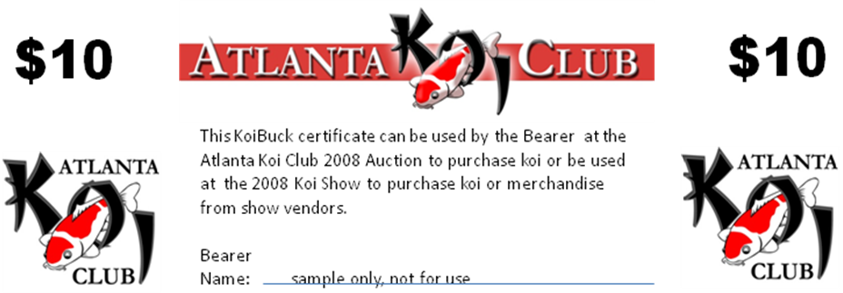

Trophy Sponsorship- Sponsorships range from $25 to $200. The names of all sponsors will be listed on the AKC website, unless you request anonymity.

One complimentary ticket to the Banquet will be given for each $100 in sponsorship costs (this can be a single award or a combination), so that you can present your sponsored trophies at the Awards Ceremony.

To sponsor a trophy contact:
Gary Elmore by phone at 404.432.5301or via email at koishow@atlantakoiclub.org

Trophies for Koi will be awarded in the following categories:
Trophy | Sponsorship Cost | Selected From
Grand Champion | $200 | All entries
Reserve Champion (A and B) | $200 | All entries
Best Jumbo | $100 | Size 6
Adult Champion (A and B) | $100 | Size 5 and 6
Young Champion (A and B) | $100 | Size 3 and 4
Baby Champion (A and B) | $100 | Size 1 and 2
Most Unique | $50 | All entries
Best Novice | N/A | All novice entries (Exhibitor is showing koi or long fins for the first time)
Best in Size 1, 2, 3, 4, 5, 6 | $50 each | All entries within size
Best Kohaku | $25 | All entries within variety
Best Sanke | $25 | All entries within variety
Best Showa | $25 | All entries within variety
Best Utsuri | $25 | All entries within variety
Best Bekko | $25 | All entries within variety
Best Asagi/Shusui | $25 | All entries within variety
Best Koromo/Goshiki | $25 | All entries within variety
Best Kawarigoi | $25 | All entries within variety
Best Hikari Muji | $25 | All entries within variety
Best Hikari Utsuri | $25 | All entries within variety
Best Hikari Moyo | $25 | All entries within variety
Best Tancho | $25 | All entries within variety
Best Gin Rin “A” | $25 | All entries within variety (Kohaku, Sanke, Showa)
Best Gin Rin “B” | $25 | All entries within variety (Utsuri, Bekko, Asagi/Shusui, Koromo/Goshiki, Kawarigoi, All Hikari)
Best Doitsu | $25 | All entries within variety

Trophies for Long fins will be awarded in the following categories:
Trophy | Sponsorship Cost | Selected From
Grand Champion | $100 | All entries
Reserve Champion | $75 | All entries within size
Best in Size 1, 2 | $50 each | All entries within size

Trophies for Goldfish will be awarded in the following categories:
Trophy | Sponsorship Cost | Selected From
Grand Champion | $100 | All entries
Reserve Champion | $100 | All entries
Baby Grand Champion | $50 | All entries under 3 inches
Novice Exhibitor | N/A | All novice entries (Novice Exhibitor is showing goldfish for the first time)
Best in Size – Mature, Young | $100 | All entries within size
Best Oranda - Mature | $25 | All entries within variety - 3 inches and over
Best Oranda - Young | $25 | All entries within variety - under 3 inches
Best Ryukin - Mature | $25 | All entries within variety - 3 inches and over
Best Ryukin - Young | $25 | All entries within variety  - under 3 inches
Best Ranchu/Lionhead - Mature | $25 | All entries within variety - 3 inches and over
Best Ranchu/Lionhead - Young | $25 | All entries within variety  - under 3 inches
Best Eye-growth - Mature | $25 | All entries within variety  - 3 inches and over
Best Eye-growth - Young | $25 | All entries within variety  - under 3 inches
Best Pond Variety - Mature | $25 | All entries within variety  - 3 inches and over (Single-tail, Wakin, Jikin)
Best Pond Variety - Young | $25 | All entries within variety  - under 3 inches (Single-tail, Wakin, Jikin)
Best Special Variety - Mature | $25 | All entries within variety  - 3 inches and over
Best Special Variety - Young | $25 | All entries within variety - under 3 inches

